* We always want to assign the .Button class and then conditionally we want to assign the .Success or .Danger class.  
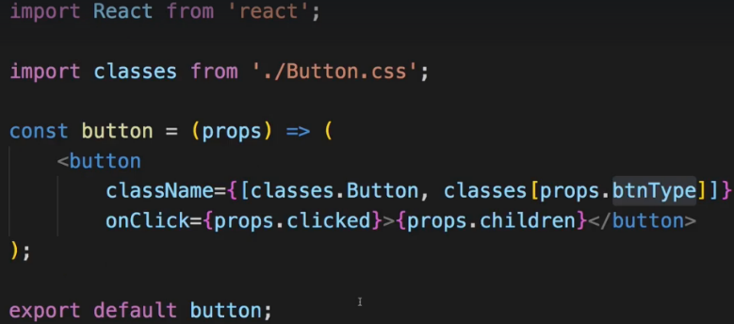  
* And of course you could also use a different approach of assigning the classes, I like this one because it’s really flexible and easy to implement.  
* Keep in mind that what we pass in className has to be a string, right now it’s an array of strings though.  
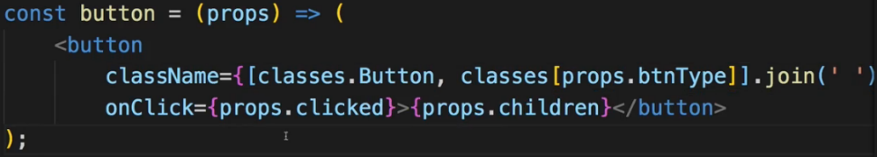  
**Implementing the Button Component**  
* In BurgerBuilder.js: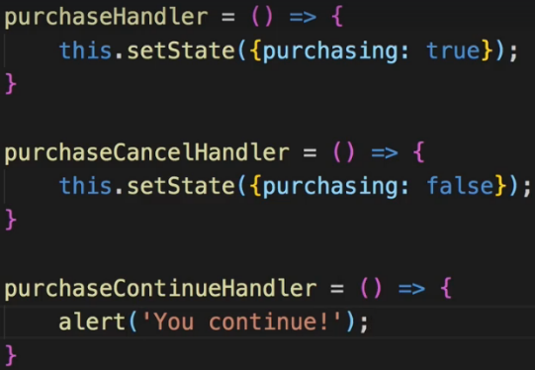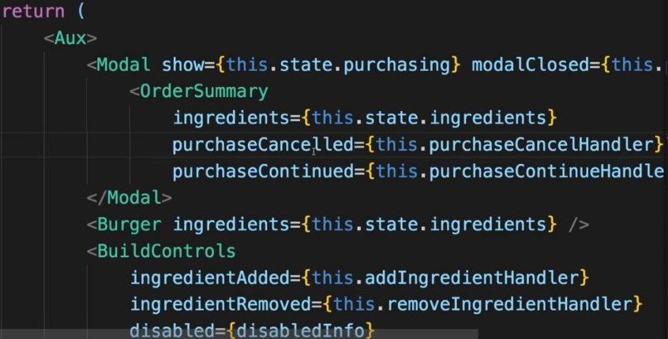  
* In OrderSummary.js:  
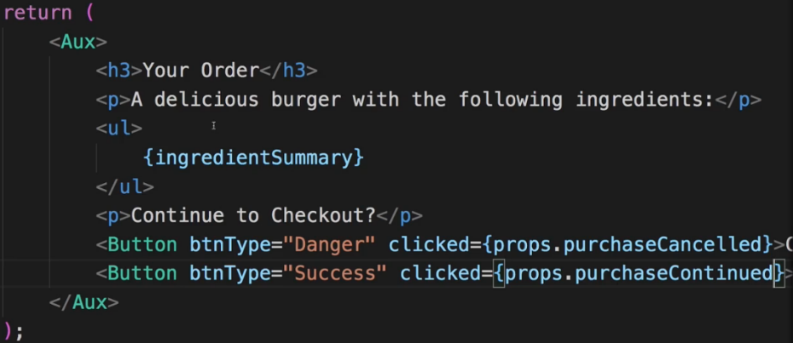

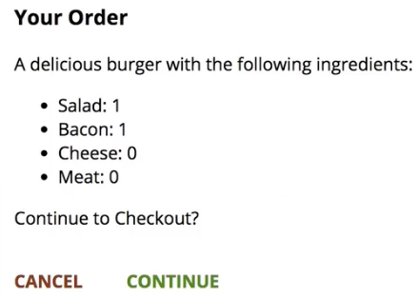  
=> This is the Modal.  
=> And this is the Burger Builder as far as we can build it from a Build the Burger side.  
=> Later we’ll also add functionality to really kind of make the purchase and store that in a database on a real server where we then probably would process the order if it were a real app. And we’ll also add more pages so that the user can also see a page of the orders he placed. And of course we’ll also overhaul this app with Redux  
* We’re not done yet though - what’s missing?  
=> Toolbar, SideDrawer, and the Backdrop for this SideDrawer. Well at least we got that Backdrop.  
**Adding the Price to the Order Summary**  
* I just noticed that if we order the burger, we don’t see the total sum in the OrderSummary.  
* In OrderSummary.js.  
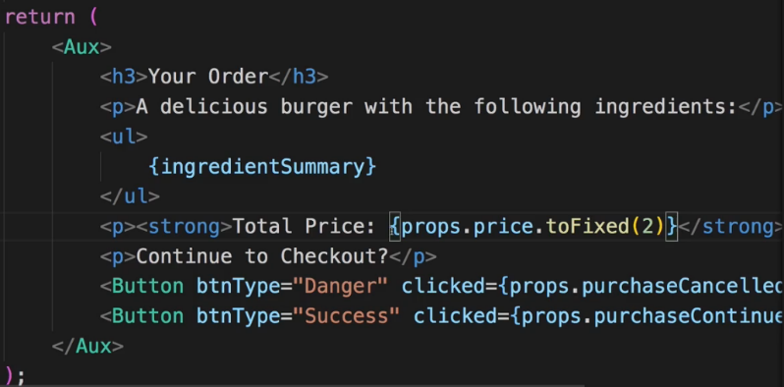  
* In BurgerBuilder.js.  
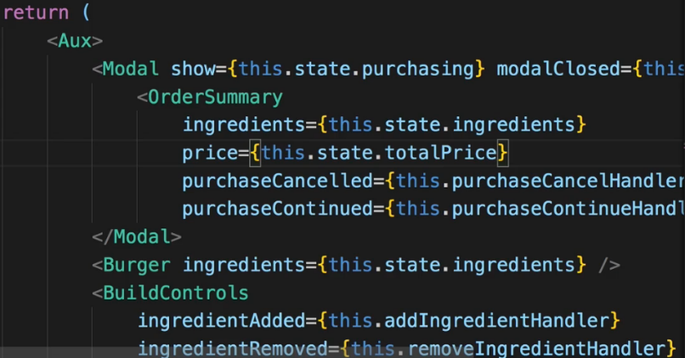  
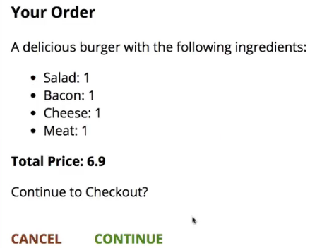

**Adding a Toolbar**  
* Every application should probably have a Toolbar, it makes it look better.  
* I want to have a wrapping <header> element because the Toolbar is the header of my Web Application.  
=> Now inside, I want to have some button which opens the SideDrawer. For now we have this DIV containing MENU placeholder though.  
=> Then I also want to have a DIV which contains my LOGO and we’ll have to add this.  
=> And thereafter I want to have a NAV item which contains my navigation links. So basically this will contain some UL with all the links, I’ll just leave the … palceholder.  
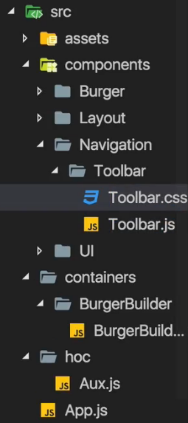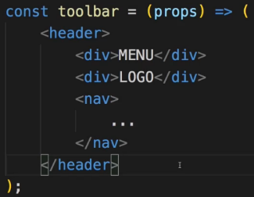  
=> All these 3 could be components which we could reuse.  
* Our CSS is mobile-first. For Toolbar, most settings should work for both mobile and desktop which is why we start with the Toolbar.  
* We use z-index: 90, this has to be lower than the z-index for the Backdrop, where we have 100 because the Backdrop should go above the Toolbar.  
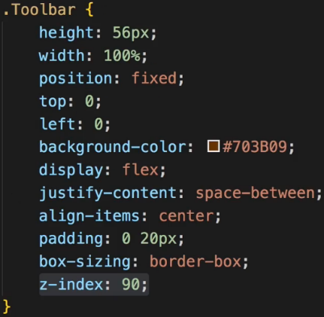 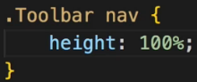  
* Now I want to control how the NAV item is displayed when nested inside a .Toolbar.  
* There I want to set a height of 100% too so that in the navigation I can then also control the height, relative to the Toolbar height and can make sure that the navigation items span full height of this Toolbar.  
* Now where should be add this Toolbar?  
=> You could argue that you want to add it in the BurgerBuilder because that is where we want to have a Toolbar at the top but in the end we want to have a toolbar at the top of any page we load. Therefore we could use the App.js file but the best place, of course, is our Layout. This in the end is about laying out our page. And this is where we already added some placeholders for the toolbar.  
* In Layout.js:  
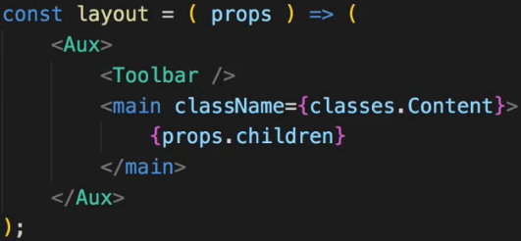  
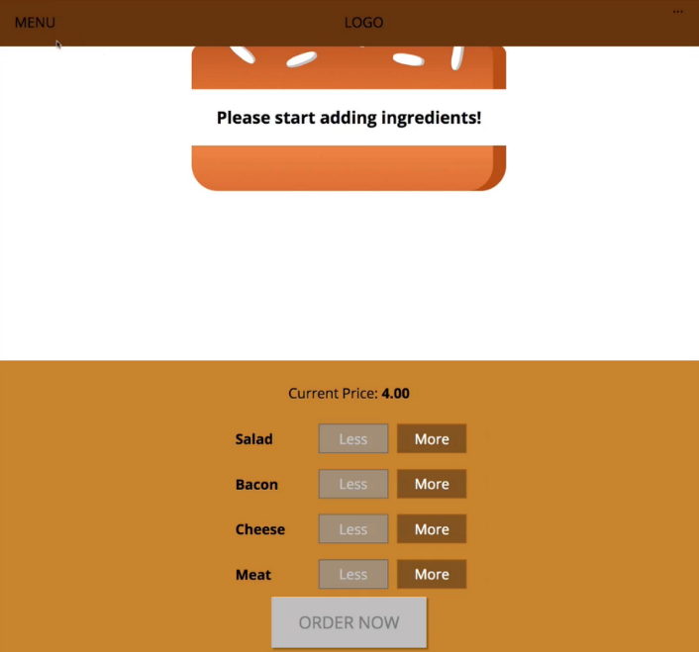  
* Now the text should probably be white. But we’re going to replace all these things with some real content later anyways.  
* We can also notice that our main page here is overlapped by the Toolbar.   
* So that <main> element here which has margin-top: 16px, should probably add these 16px to the Toolbar height of 56px which we set up.  
=> In Layout.css we want to change margin-top: 16px to +56px so 72px.  
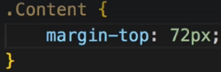  
* Now the burger is nicely positioned again. Now let’s work on the logo.  
**Using a Logo in our Application**  
* I’m not going to add the logo to Navigation, I’m going to add it to components because theoretically we could use the logo anywhere in our application.  
* Now I actually want to use an img file as a logo.  
=> So I’m going to store that image file in the `assets` folder and create `images` sub-folder.  
* It’s a burger with a transparent background.  
=> Now I want to simply display the image in Logo.js, I also want to wrap it in a DIV which sets the background for the image though, because the image itself has a transparent background and I want ot set a white one here.  
* And of course we could even go so far to accept the background color via props and change it dynamically if we wanted to.   
* Now the `src` on the `img` should actually be set dynamically. You could think that you simply say go up to the assets folder > images > burger-logo.png. Now this will not work as you would expect it to work due to the way our build workflow is set up. Keep in mind the `src` folder is only the folder we’re working in, in the end webpack will take all these files, bundle them together and create a new output folder. We can’t see that here because we’re in development mode where all of that will happen in memory but once we do publish our app, we will get a real different folder where all the optimized, compiled and bundled assets are contained in.   
=> **Now therefore this assets folder in the `src` folder will not be shipped to any real server. The whole `src` folder won’t be shipped there. Hence we should also make webpack aware of the fact that we’re using this image and we’re actually doing that by importing the image into our JavaScript file**.   
* Now of course, just like for the CSS files - this does not mean that webpack mixes the image with our JavaScript code. It just means we make webpack aware of the fact that we’re using this image and webpack will then handle this image with a special module that was added to webpack to its config. We’ll basically copy the image over to the destination directory it creates - again only in memory during development. And will even optimize the image.  
* And burgerLogo here will in the end just receive the path of the image where webpack will copy it to.  
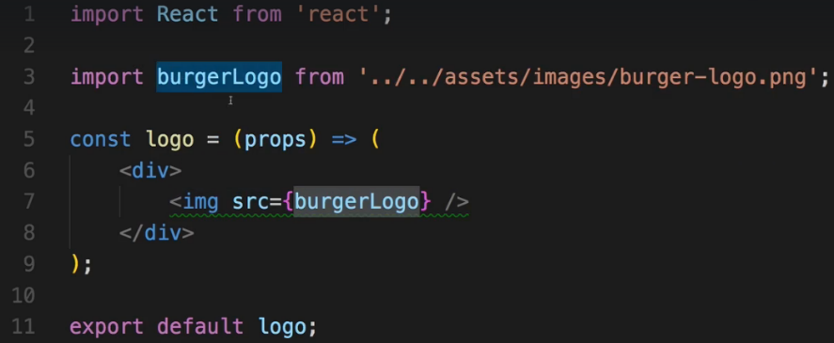  
* And this src={burgerLogo} will again refer to a string in the end, to the path where webpack stored the optimized and copied image. This is important to understand.  
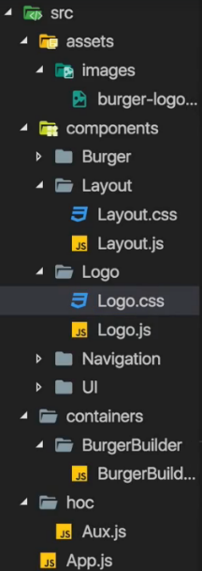 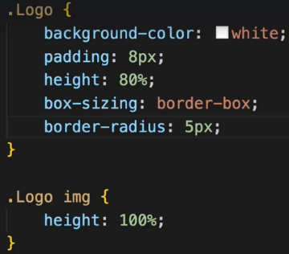  
* And now important - let’s set the image height: 100% so that the image does take this height at a maximum and it does not take its default inherent height which would be higher.  
* We adjust the .Logo height to be 80% so that there is some brown around it on top/bottom.  
* Let’s also set the box-sixing: border-box so that the 80% height also includes the padding.  
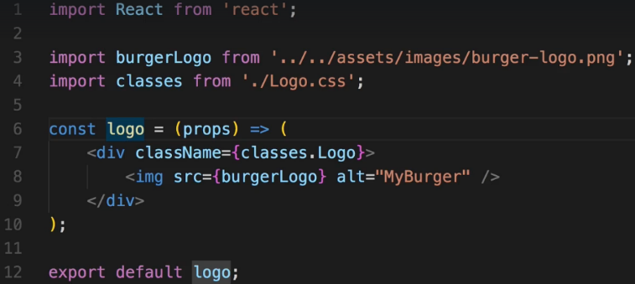

* Now I’ll go to the Toolbar.js because that’s where I want to use the Logo.  
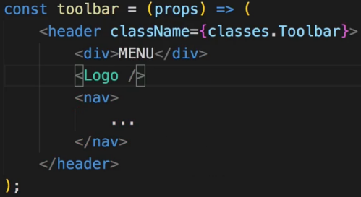  
* Now I can already say we will have to touch the styling for the Logo later on again when we start implementing this in the SideDrawer. But for the Toolbar, this should actually do it.  
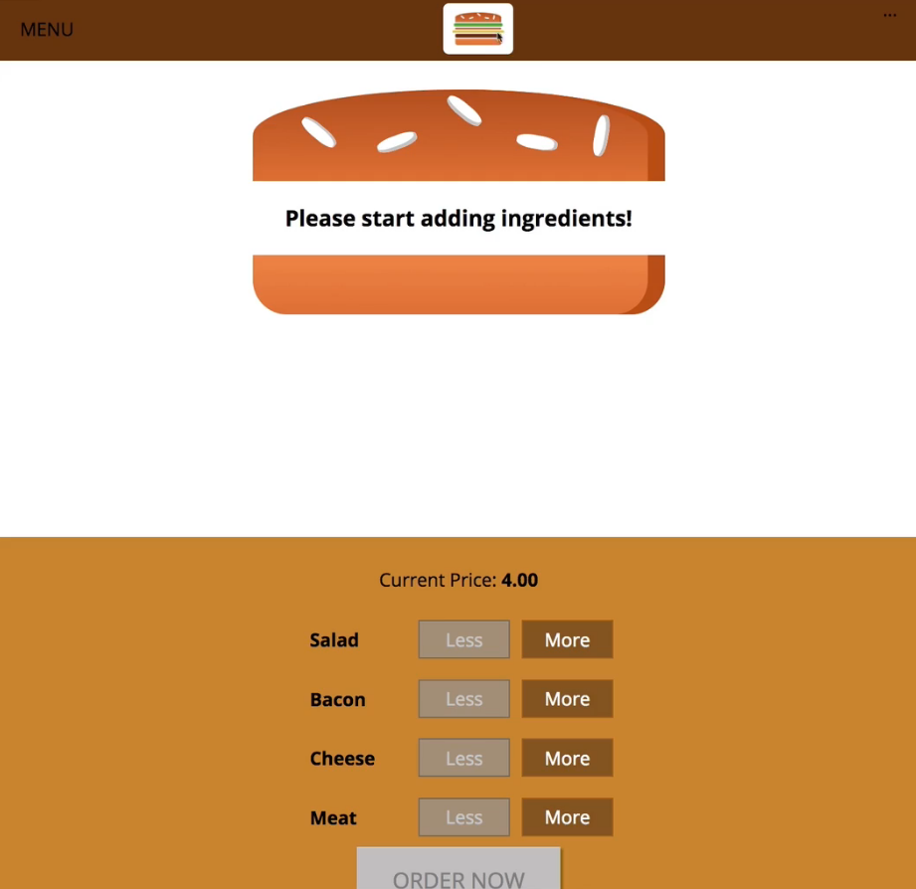  
**Adding Reusable Navigation Items**  
* Let’s outsource the navigation items into their own component becase I actually want to reuse the navigation items in the SideDrawer later on.  
=> Creating a `NavigationItems` folder in the `Navigation` folder.  
* I don’t even need the props there so I don’t need to have them in the component.  
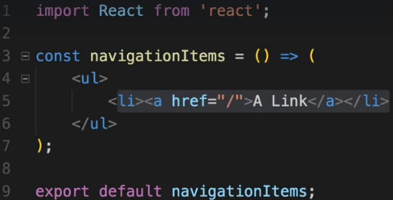  
* We can even go as far as outsourcing the single links into their own components. You could also argue for having only 1 component - the NavigationItems component which holds both the list and the individual items, but since I will add quite some styling to the individual list items, I will outsource it.  
=> Creating a `NavigationItem` folder in the `NavigationItems` folder.

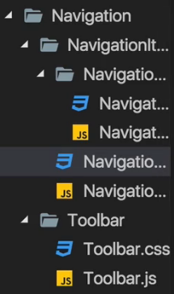 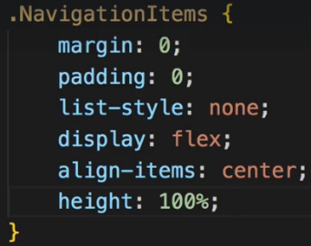  
* Now I’m actually not developing the .NavigationItems mobile-first because we don’t have the SideDrawer yet and we can’t see that and we can’t see that in SideDrawer yet for that reason.  
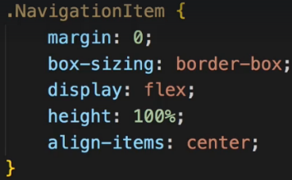 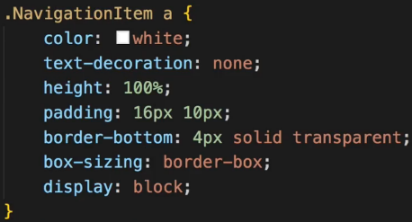 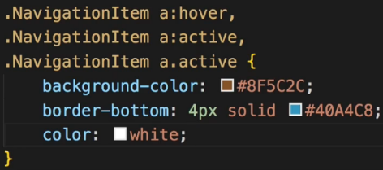  
* We need to add display:flex to make sure that I can center the link vertically, the link inside the list item. I’ll set the height: 100% because I have a special idea about how I want to have active links look.  
* The border will be invisible but this border will become important once we actually highlight a link, once we hover over it.  
* Now let’s style links which are hovered, links which are active = which are clicked on and links which have the .active class - a class I later want to assign to links on which page we are.   
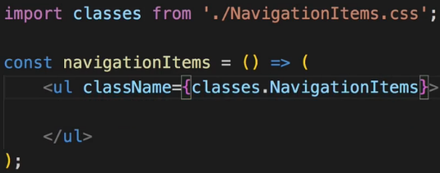 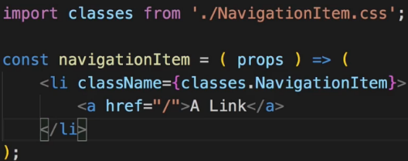  
* Now we wouldn’t see anything because right now we’re not including any NavigationItem-s in our NavigationItems component.  
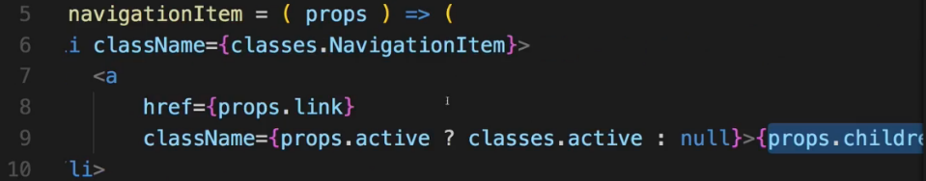  
* Now we could use `**active={true}**` but for boolean props we can just pass it like this `**active**`.  
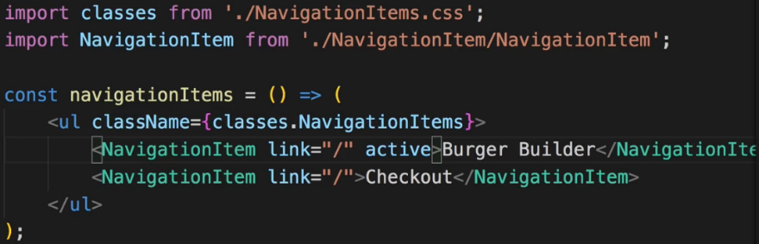  
* Now we have our NavigationItem/s set up, now we need to use our NavigationItems component in the Toolbar.js.  
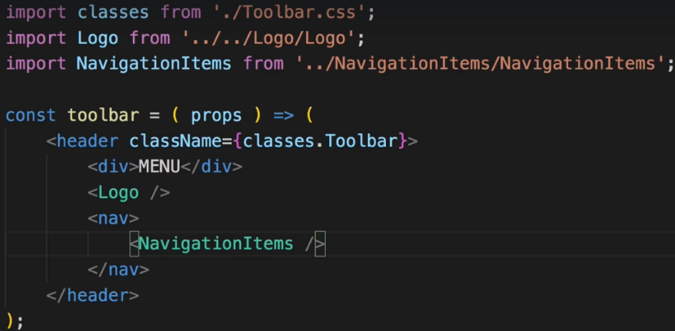  
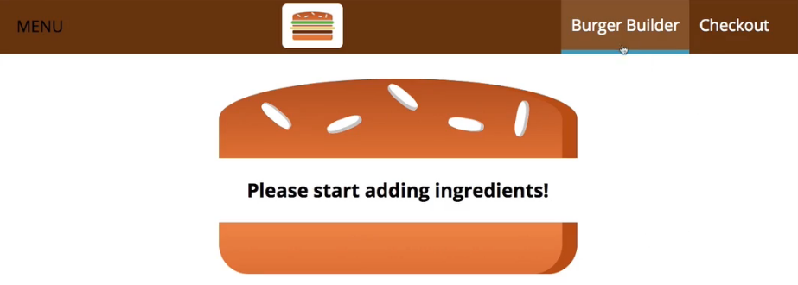  
* Now again this will have to be adjusted once we add the SideDrawer and add mobile navigation but for now it looks great. Let’s have a look at the mobile navigation next.  
**Creating a Responsive SideDrawer**  
* The SideDrawer will consist of 2 components.   
=> The SideDrawer itself and the Toggle button which right now is the placeholder with “MENU”.  
* We might reusa such a button so it should probably go into its own component.  
* Also we’ll need a Backdropfor the SideDrawer but we already got one.  
* We won’t return JSX code immediatelly but a real function body because before I return JSX in there, I want to do something - I want to conditionally attach different CSS classes to make sure we place some animation when the SideDrawer is shown.  
* Inside the SideDrawer I want to have the Logo and NavigationItems.  
* So here you can already see how we’re reusing components.  
* I’ll wrap NavigationItems into a NAV element. And yes you could also therefore outsource NAV into NavigationItems, just make sure to also adjust the styling there then because right now I’m styling NAV in .Toolbar nav, you’d have to move that into NavigationItems.   
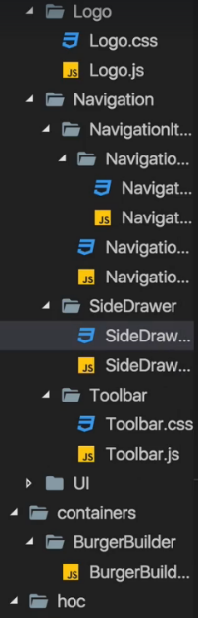   
* The SideDrawer will only be opened on mobile devices  
* We’re having z-index: 200 - deliberately having higher number than the Backdrop because the SideDrawer should be above the Backdrop.  
* Now I’ll add a transition property to react to changes of the transform property and animate them over 0.3s with the ease-out timing function. This will be important for opening and closing.  
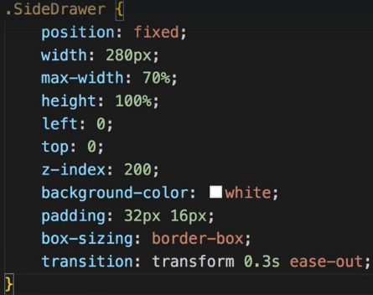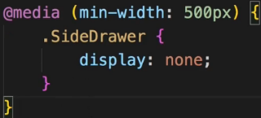  
* The translateX(0) will basically shift the SideDrawer into the position I defined in .SiderDrawer.  
* The translateX(-100%) will shift it to the left.  
* And since we constantly switch between these classes, transform will be adjusted and hence it’ll play with the transition.  
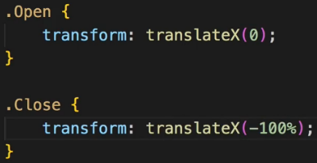  
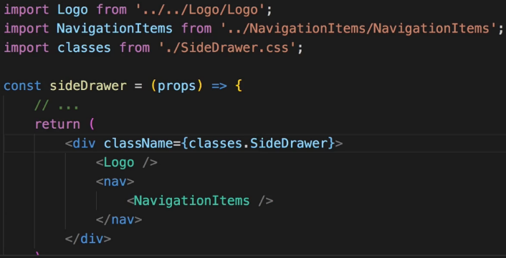  
* Where should this SideDrawer component be used at?  
* In the App.js? In the Toolbar.js? Neither of the two of course. We got our Layout.js and in the Layout we have the Toolbar, it’s here where we should also have the SideDrawer because it’s part of our core Layout in my opinion.  
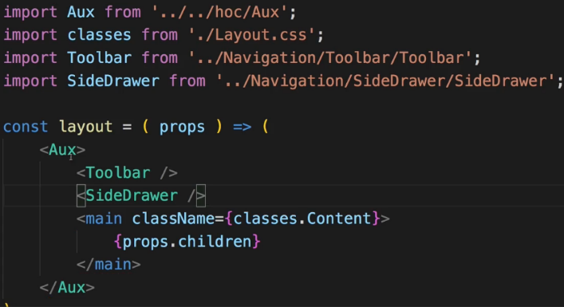  
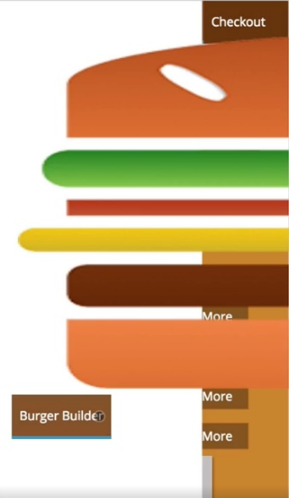  
=> Now the Logo is way too big and the NavigationItems of course look bad. That makes sense because we haven’t adjusted them to look good on mobile devices.  
**Working on Responsive Adjustments**  
* We could add some responsive design to the Logo.css, could set the default height: 11% and add a media query to ramp this up to 80% for bigger screens but that would make our Logo harder to reuse.  
=> Instead, I’m a fan of controling the Logo height in the place where we embed it instead of in the Logo component.  
=> So I will actually set the Logo.css height back to 100%.  
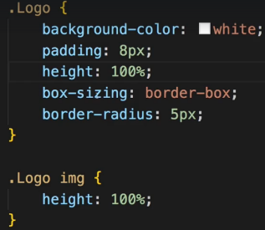  
* And we should restrict this height in the Toolbar and in the SideDrawer.  
* We can achieve this in 2 ways - we could add a prop to actually set the height dynamically and we could set the inline style={} in Logo component to overwrite the CSS class settings.  


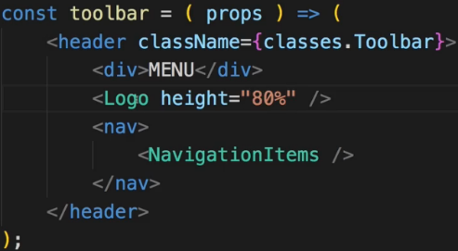 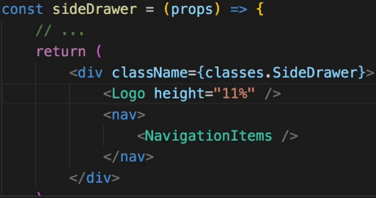  
=> This is 1 clever way of adjusting this - setting the height as a property where we simply pass the % height to the Logo component and in the component, assign it dynamically via inline styles.  
=> Nothing wrong with this approach, it should look fine.  
* I will leave the class in the SideDrawer but will do something else.  
* I will follow a different approach and wrap Logo into a DIV in the SideDrawer and also in the Toolbar. And now these DIVs which wrap the Logo - they should control the height. We can do this with inline styles or with a CSS class like for example here in the Toolbar classes.Logo. And the cool thing is I can now use the Logo class here in the Toolbar component even though I’m already using it in the Logo component because due to CSS Modules, it will convert my CSS class names into different names, into scoped names so that even though I write 2 identical classes in the development mode here, it actually converts that to 2 different classes which get assigned so that they don’t interfere.   
=> So now I can define that .Logo class in my Toolbar.  
* In Toolbar.css: * In SideDrawer.css:  
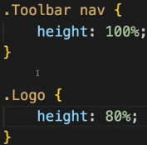 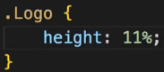  
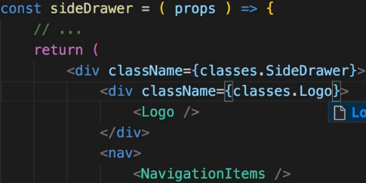 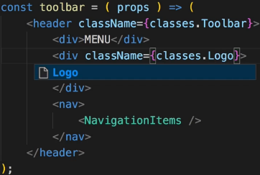  
* And again I have that .Logo class defined in 3 different files but due to CSS Modules this is actually converted to 3 different CSS classes.  
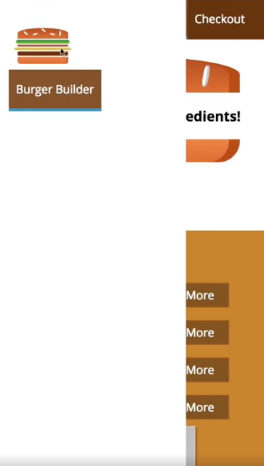 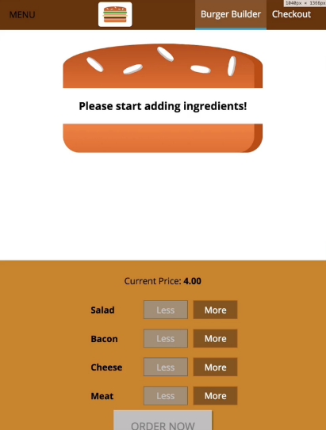  
**More about Responsive Adjustments**  
* Let’s adjust the NavigationItems with media queries in the NavigationItems.css file.  
* Currently we have it only for desktop, we will move that into a media query.  
* And now in the base styles we wanna adjust it for mobile devices.  
* I want to set the width: 100%, not the height - the height should be only taking the height it needs from a text perspective. And the display doesn’t have to be flex, it can be block here. And I don’t need that align-items for that reason.  
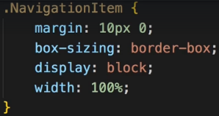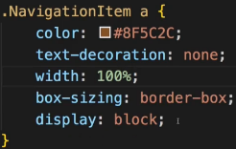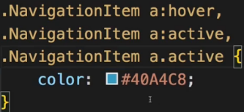  
* Now let’s throw out any duplicate styling we have in desktop media query.  
* For desktops we will use width: auto, not the 100%.  
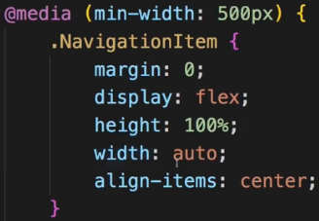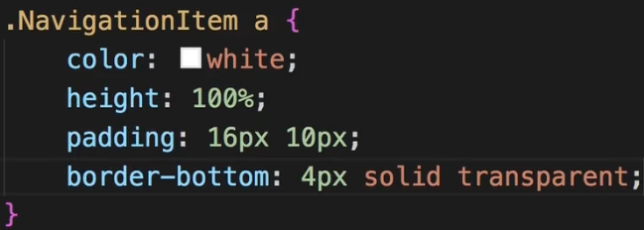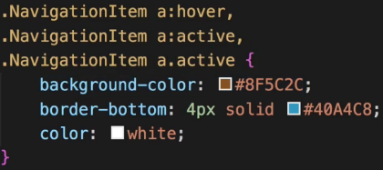  
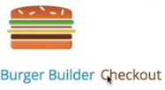  
* Now they’re still sitting next to each other - the reason for this is that in our NavigationItems the UL which wraps the links - there we’re using flexbox.  
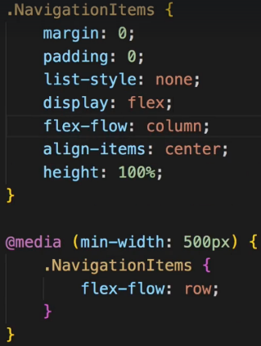 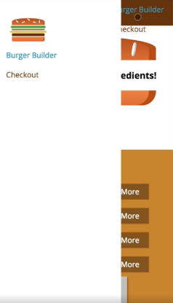  
* When using Chrome Dev Tools different heights/width - the distorted burger when switching is only due to the switching, once you reload and load the app as the user would see it, it’s looking fine.  
* Now we got issues here - the NavigationItems are also visible on the Toolbar on smaller screens, I also want to have a bit more spacing between the logo and my NavigationItems here.  
=> To fix this, in the SideDrawer where I include the Logo and the NavigationItems, I’ll first of all add some margin-bottom on the Logo.  
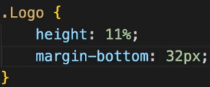  
* And to remove the NavigationItems in the Toolbar we actually need to add a new helper CSS class which I’ll add to the wrapping element. We use max-width media query so that it applies to mobile devices.  
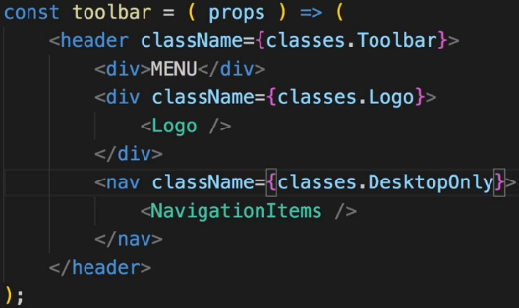 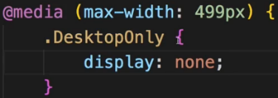  
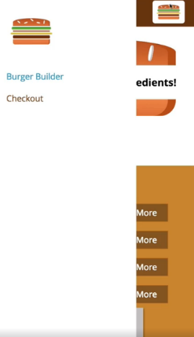  
=> We see the Logo here on the right but I think that looks quite nice so maybe we’ll leave that here.  
=> It would look even better if it had a Backdrop and if we could dynamically open and close it.  
**Reusing the Backdrop**

* Just as I added it to the Modal component - I included it in the Modal component, I want to include it in the SideDrawer component too because it belongs to the SideDrawer.  
* To solve the adjacent elements we can import our **Aux HOC**. --- or use **FRAGMENTS <> </>**.  
* Now we don’t see the Backdrop though - our Backdrop.js has this props.show to display it.  
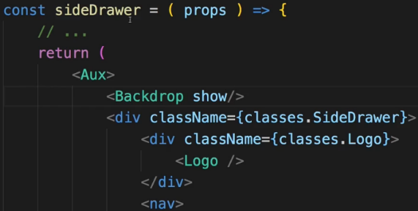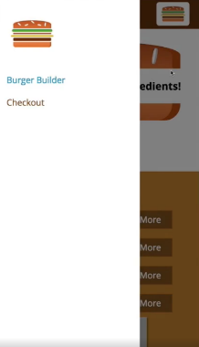  
=> So now we got the Backdrop. This should not always be visible though - the SideDrawer should only be shown sometimes - once we click the menu button essentially and it should also be closed once we click the Backdrop.  
=> So for that we need to register a click listener on the Backdrop and actually we already have one. We have the onClick={props.clicked} which can fire any method we want it to fire.  
=> So the goal is to now be able to handle this method in the SideDrawer. Now in the Modal.js we simply propagated this click up so up to our holding container. Here in the SideDrawer I also want to do this. We could also turn the SideDrawer into a Stateful component and handle the click in here with a method and with a state which we switch from show so from true to false. And there would be nothing wrong with it but we will also trigger the SideDrawer from the Toolbar in the end because there we’ll have the MENU button. So in the end we also need to create a connection from Toolbar to SideDrawer and we have that connection already - it’s the Layout.js component. This is where we use both.  
=> So in my opinion it makes more sense to turn the Layout component into a class component where we can implement the method so that we can listen to both the SideDrawer closing itself by clicking on the Backdrop as well as the Toolbar opening the SideDrawer by clicking on the Toggle menu button.  
=> So let’s turn our Layout into a class and extend (so import) Component from React.   
=> Let’s also change the name if the class to Layout since that’s the convention (Stateful = Capital, Stateless = lower).  
* Let’s set the showSideDrawer to true for testing, later change the default to false.  
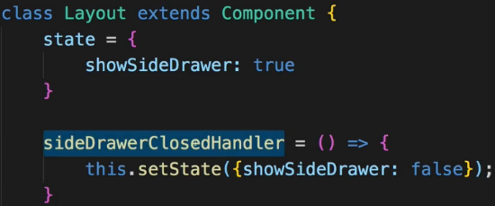  
* Now let’s pass this event handler method to my SideDrawer.  
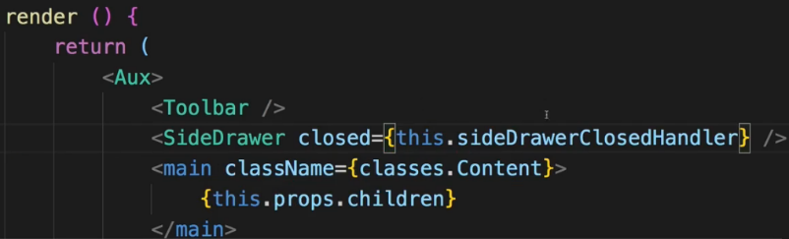   
* In the SideDrawer we’ll use to to simply pass it on to the Backdrop where I have this clicked property which will simply pass me the onClick event basically.

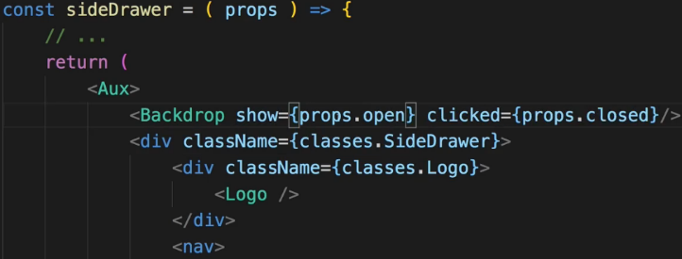  
=> So simply setting up this chain where I pass down the method reference to the place where I handle the click in the end.  
* We also pass this show from Layout.js state.  
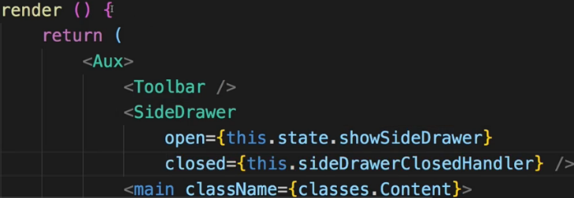  
=> Now if we click the Backdrop, it dismisses the Backdrop. It doesn’t dismiss the SideDrawer yet because we haven’t implemented any logic to do so. Let’s do it now.  
=> We have the .Open and .Close CSS classes in the SideDrawer.css file. I want to attach these classes conditionally because they will basically move the SideDrawer out of the page or into it and they will play an animation with it due to that transition property here.  
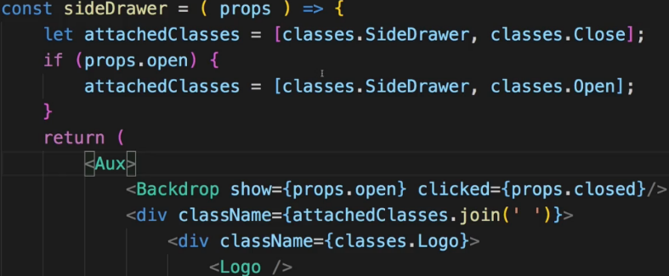  
* Now both the SiderDrawer and the Backdrop disappear when we click the Backdrop.   
**Adding a SideDrawer Toggle Button**  
* Let’s now implement a component which allows us to click on it and which will then trigger something which shows the SideDrawer. There are certainly more than 1 way of achieving this.  
=> For example by not creating a component and simply hooking up this DIV “MENU” with click listener to take an easier route. Or outsource this into its own component, maybe create a Hamburger icon there, make it clickable and in the end make sure that you somehow get to the Layout component and adjust the state to set showSideDrawer to true. Set if false initially. And make sure that you now can somehow click something in the Toolbar, set the state here as I just said and therefore change the open property of the SideDrawer because it’s dependant on the showSideDrawer state.  
=> We want to make sure that we can click this “MENU” button in the Toolbar. And I want to outsource “MENU” into its own component which I want to also style as a hamburger icon.  
=> I’ll place this component in a SideDrawer folder because it belongs to the SideDrawer and I’ll name it `DrawerToggle`.  
* I will add this DIV “MENU” as a placeholder but I will change this to a hamburger icon later.  
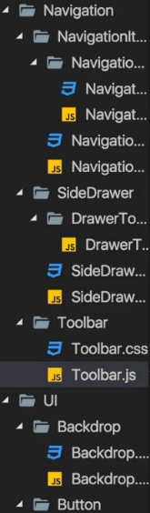 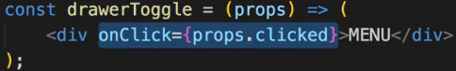 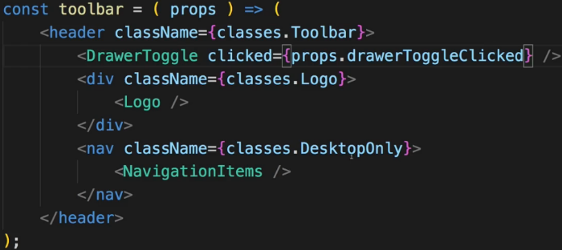  
* Now the goal is to add a click listener to the DIV here.  
* Now in Toolbar let’s add that clicked property to the DrawerToggle and there of course we don’t have that method defined in here - but we will use the Toolbar in the Layout component where we will add this method. So ultimately we will set some property on the Toolbar and pass down the method reference from there.  
* Now in the Layout.js we’ll add that sideDrawerToggleHandler. Now it actually will work as a toggle so from open to close and the other way around, but in our app we will never be able to see that close functionality because the SideDrawer will overlap it - I’m still going to create it in this way because if we ever were to add this toggle in some other place in the app, it would really work as a toggle.  
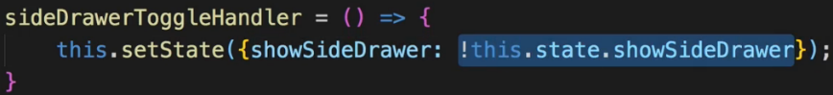  
=> This approach here has a flaw though. I mentioned earlier that if you plan on using the state in setState(), you shouldn’t do it like this because due to the asynchronous nature of setState(), this may lead to unexpected outcomes.  
=> So instead, use the **function form of setState()**. This is the clean way of setting the state when it depends on the old state.  
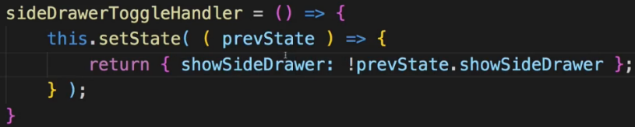  
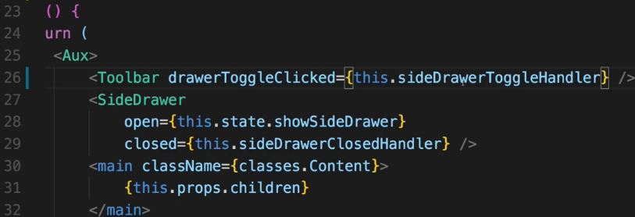  
=> Now if we click the “MENU” button, the SideDrawer slides in. Let’s now turn this “MENU” text here into a hamburger icon.  
**Adding a Hamburger Icon**  
* We add DrawerToggle.css file.  
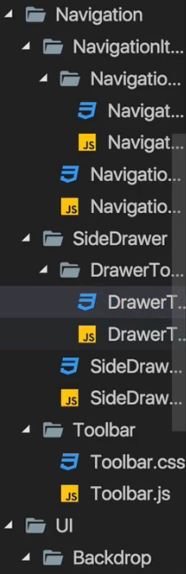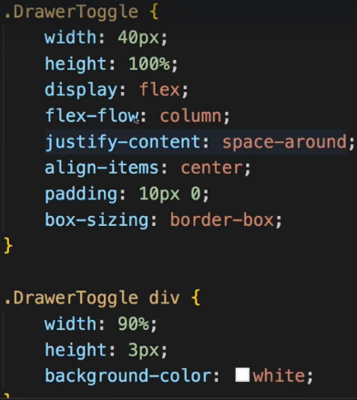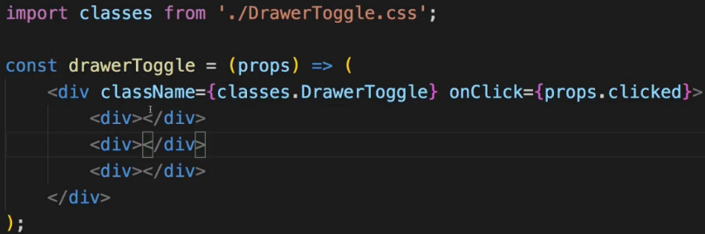  
* Now attached to this video you will find the CSS code which is responsible for styling it as a hamburger icon.  
=> Now this code essentially just creates a DIV with 3 bars inside of it where each bar is one of the hamburger icon bars.  
=> Now to make this CSS code work, we need to adjust the actual HTML(JSX) code instead of just the “MENU” text.  
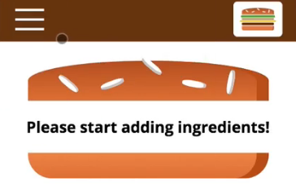  
* Now later we’ll add more functionality like sending this order data to a real server, adding multiple pages and handling the application’s state differently.  
* Let’s now have a look at how we may optimize this or what we can fine-tune about that.  
**Improving the App - Introduction**  
* Of course we want to have a really good application not only by the looks of it but also by the way we structure it, we work with it.  
* Now throughout building this application, I already showed you a lot of best practices for building that, I shared my thought process on how to structure and plan the application and I gave you some alternatives at some points of time on how you may split something into components.  
* Here we have a relatively granulad component structure. You could certainly combine some of the components we’re using.   
* But can you also improve some things? Let’s dive into 2 important things we learned about:   
=> PropTypes  
=> PureComponents - so shouldComponentUpdate()  
=> And let’s also have a look at all these Lifecycle methods. Do we use them in there? Why don’t we use them at any point right now? Where would we use them?  
**Prop Type Validation**  
* Right now we’re doing Prop Type Validation in BurgerIngredient component.  
* There we make sure that the `type` is set so that it is required and that it is a string.  
* I’m not doing validation in any other component.  
* And the reason for this is that here I’m not working on a project which is going to get used by other people, I’m not working on a third-party library, I’m not even working in a developer team, so a lot of the reasons why properties might be used incorrectly aren’t relevant here. Additionally, we’ll get logical errors in our application if we forget or assign a wrong key property anyways and that is why I don’t use Prop Type Validation that much in this application.  
* If you add some Prop Type Validation, just keep in mind that you’d have to have Stateful Components, which isn’t bad per se, you can absolutely do that but it’s also good practice to not unnecessarily do that and instead use as many Stateless, Functional Components as possible. And therefore only really do it if it makes sense.  
**Improving Performance**  
* What about PureComponents and shouldComponentUpdate()?  
* Now let’s analyze the application:  
=> Do we have any state or prop changes which trigger a re-rendering even though this might not be required?  
* Most clicks we do really change the UI and therefore should trigger updates, should trigger re-renderings of these components.  
=> So we shouldn’t really lose performance there. And using a lot of PureComponents for unnecessary shouldComponentUpdate() checks might even hit the performance more than doing an occasional unnecessary re-rendering.  
=> Crucial points we should check are of course our: BurgerBuilder Cointainer - there we change the state but whenever we do change the state, it really affects our application and we do need to re-render stuff.  
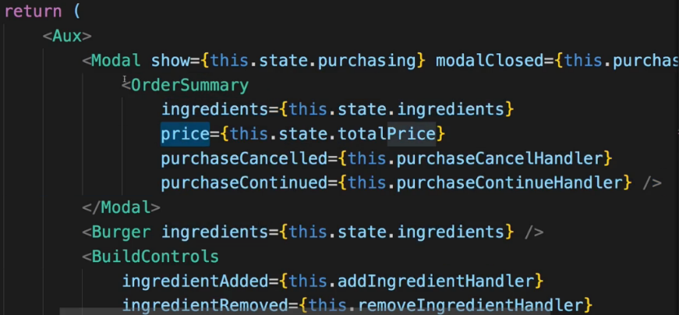  
=> I can identify 1 element here though, where we might be able to save some performance by not re-rendering it unnecessarily and that is the Modal component. It wraps the OrderSummary and that of course means that whenever ingredients or the price changes since these are props of OrderSummary, OrderSummary will be re-rendered, however, if the Modal is not visible, we don’t need to do that.  
=> So actually only if the Modal is shown, re-rendering of that wrapped element here makes sense. So that is something we might wanna check and control.  
=> So let’s first of all find out when OrderSummary is re-rendered by simply adding a Lifecycle Hook to it.  
=> Let’s turn it into a class component so that we can add Lifecycle Hooks so that we can see when this is updated.  
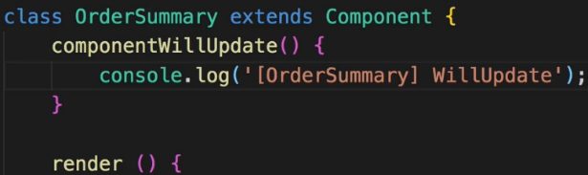  
=> If we add an ingredient, the OrderSummary updates. So it doesn’t really make sense to re-render that when we don’t see it.  
=> Now let’s see if that changes if we make sure that Modal doesn’t update unnecessarily.  
=> For that let’s turn Modal into Stateful Component as well so that we can implement shouldComponentUpdate().  
=> Let’s now see if we can control the updating of OrderSummary - which is wrapped by the Modal, by changing the way the Modal itself updates.  
=> Now I want to make sure that this only updates if this.props.**show** changes. Because that’s the only thing which matters for me here.  
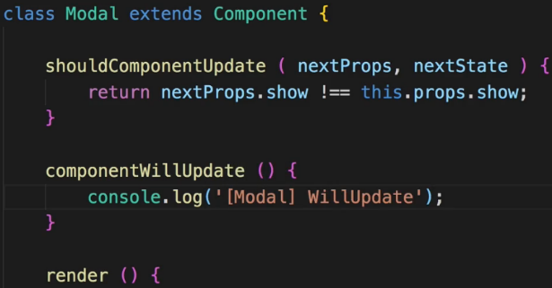  
=> Now it updates once we click ORDER NOW  
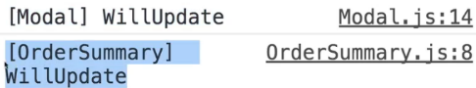  
=> So here we definitely improved our application because we make sure that we don’t unnecessarily update OrderSummary, that we don’t unnecessarily re-render that.   
=> And you also see that **the wrapping element controls the updating of the wrapped element**.  
=> So OrderSummary theoretically - the component - is included in the BurgerBuilder but it is not updated because the wrapping element Modal has a shouldComponentUpdate() method where we control this.  
* What we don’t do - we don’t react to changes in the clicked listener so if the `modalClosed` property would change, we’re not checking this. So we only return true if the `show` changed. It’s okay here in this application because we actually never reassign this clicked listener. If we were to do that, or if we were to also change `state` in the Modal, we definitely should also check for changes in other props, other state properties, or simply extend PureComponent.  
=> Here I’m not using PureComponent because PureComponent would run more checks than I want to do - it would also check for `modalClosed` to be changed and I’m not interested in that so my method should be even more straight forward, even more focused.  
* Now with that we can of course also turn our OrderSummary back into a Functional Component to no longer output componentWillUpdate() here but I’ll leave it here for debugging purposes, for reference, but I will comment that this could be a Functional Component.  
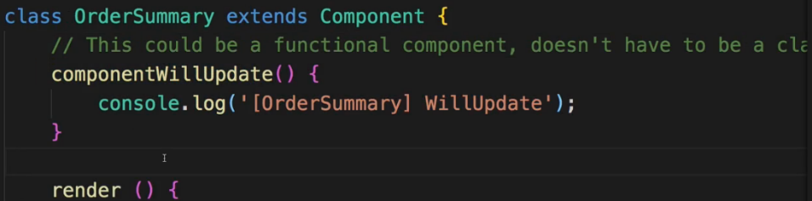  
* shouldComponentUpdate() is definitely not required here because we don’t need to check this, this always needs to be updated if the Modal is shown and the Modal is where we do check whether it needs to be updated or not.  
**Using Component Lifecycle Methods**  
* Now what about other Lifecycle Methods like componentDidMount() or componentDidUpdate() and all these things? Why don’t we use any of them? When would we use them?  
=> Well actually you will see some of them being used once we add HTTP.  
=> As you saw in the slides in the last course module, **the componentDidMount() and componentDidUpdate() Lifecycle Hooks are extremely important** **for causing side-effects**.  
=> That shoulds strange but in the end just means things like reaching out to a web service and fetching data from there. Now we’re not doing that yet in the application. There isn’t much initialization we have to do in our components. That is why we don’t need the Lifecycle Hooks.  
=> Other Hooks like componentWillUpdate() and so on which we don’t use except for logging here, well you typically don’t use these that often. **There might be some cases where you need to adjust your component STATE based on some PROPS you receive from outside and that certainly can occur in bigger React applications but it’s also not that uncommon to have React applications where you don’t use that many Lifecycle Hooks except for componentDidUpdate() maybe**. So that is the reason why you don’t see that many of these being used. There will be more once we add HTTP.  
* It’s a pretty good application, showing a lot of features of React and a lot of best practices so let me now summarize it in the next lecture.  
**Changing the Folder Structure**  
* Our Layout.js is clearly a Class-based Component and it has a STATE, a state to handle the display of the SideDrawer.   
* Now I don’t really consider it to be a Container though you could argue for it to be one because obviously it contains some other components and it passes state down to them. So it wouldn’t necessarily be wrong to place that Layout component here in the `containers` folder. Like this:  
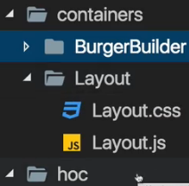  
* You could also argue for something different - with the given folder structure, which of course is also just 1 possible way, where I have this `hoc` folder for Higher Order Components, you could kind of argue that the Layout.js is really just a HOC because what you’re doing with it is you’re wrapping your other components with the Layout. So the BurgerBuilder component in our application, but once we add ROUTING, that of course are going to be more components. And in the App.js folder we’re really just wrapping the BurgerBuilder with our Layout component. And this essentially makes it a HOC. These are mainly just semantics - it doesn’t really change the way your application works the how you call your components.  
* Still you could move the Layout into `containers` or you could move it into `hoc` or maybe in your application you don’t really have a `hoc` folder. Maybe there you just have `containers` and `components`. There is more than 1 correct way.  
* Now I like this setup though where the Layout is now in the `hoc` folder because I consider it a HOC. It’s only there to wrap other components. And therefore here we’re using it in the App.js file to wrap whichever ROUTER rendering, hence I move it into the `hoc` folder.  
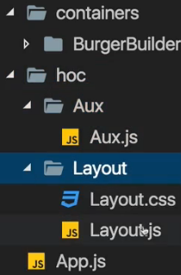 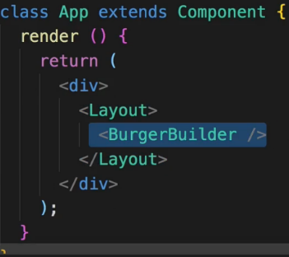  
* Now this will lead to some errors because we will have some import issues.  
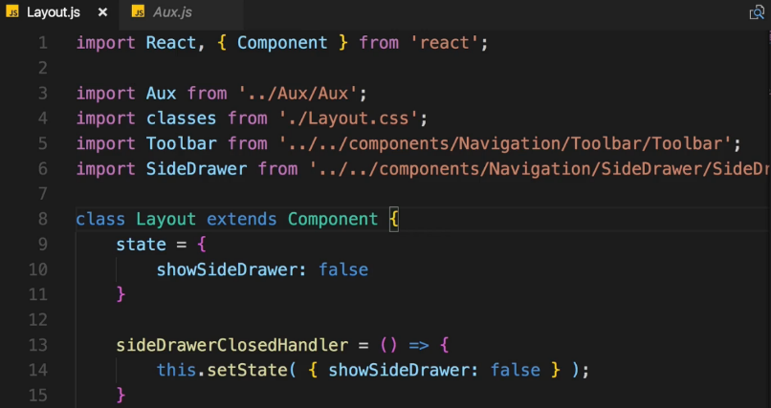  
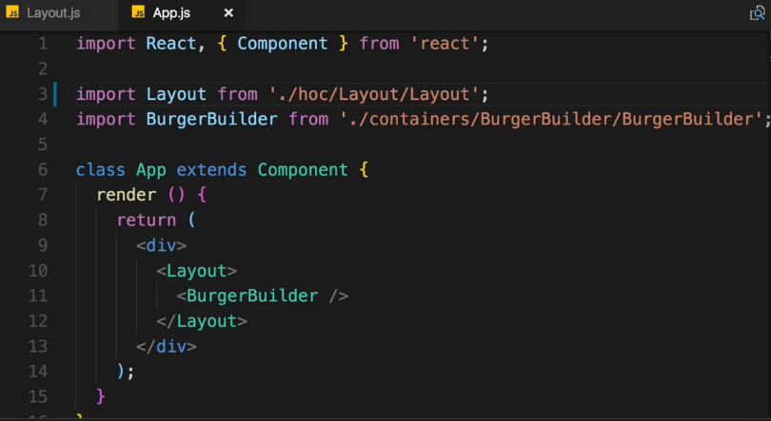  
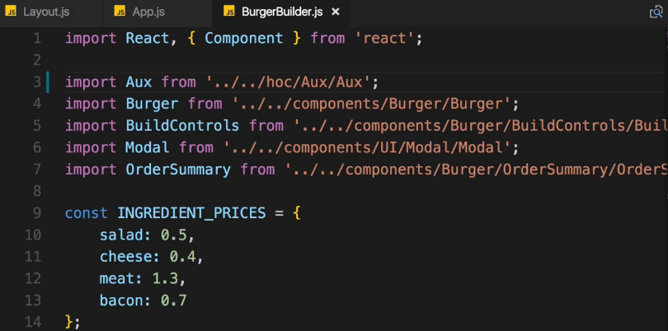  
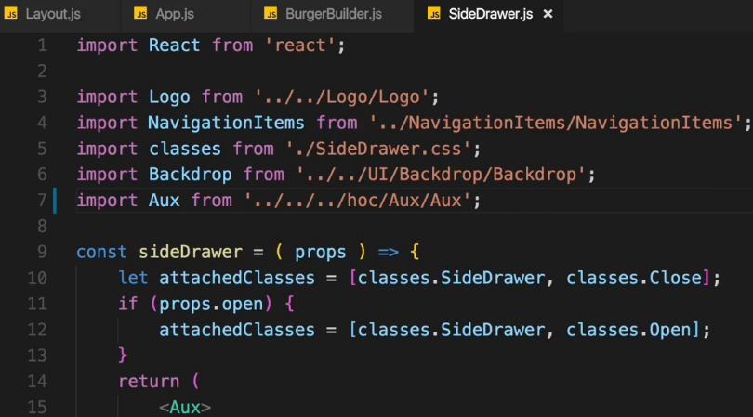  
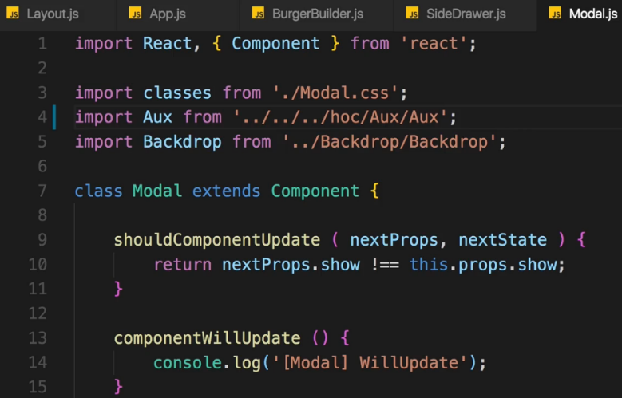  
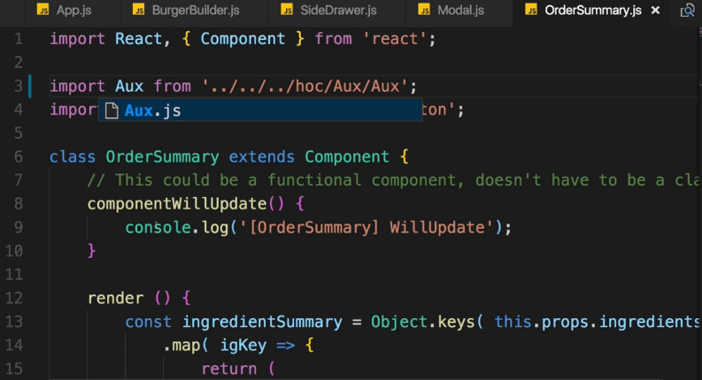  
=> With all these changes now we should have a working application again.  
* This new project structure is optional but makes more sense in my opinion due to the way our components do work.  
* Now with that we really have a great application, let’s now move on.  
**Wrap Up**  
* You learned how to plan your application, how to split it into components, how to have these components communicate with each other via PROPS, how to pass METHOD REFERENCES to components so that a CLICK on the BACKDROP triggers a METHOD in ANOTHER COMPONENT like in the LAYOUT component in our case.  
* These are all CORE CONCEPTS of Modern React Applications.  
* Being aware of how to communicate, how to structure it, how to build the components and the pitfalls React offers.  
* Being aware of concepts like the **Aux/Auxiliary HOC** --- newly **FRAGMENTS <> </>**.  
* Or the shouldComponentUpdate() mechanism.  
* These are crucial to building successful React apps.  
=> We’ll learn much more: how to reach out to the WEB to SAVE your DATA there or FETCH it from there.  
=> You will learn how to handle STATE in a BETTER WAY.  
=> How to ROUTE.  
* But here you got solid foundations and you can play around with this project, enhance it a little bit, add some features, change the styling, add other components, add more ingredients to the burger, whatever you like.   
* Building projects is the best way of learning anything.